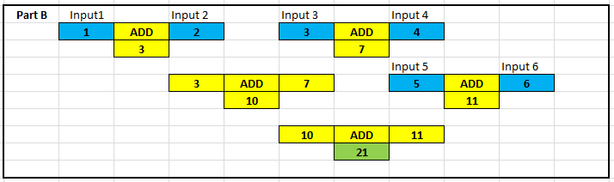

Input 1 and 2 add together, input 3 and 4 add together, the results add together. Then input 5 and 6 add together, then that adds to the total to get 21.

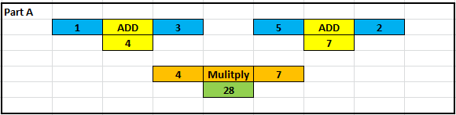

Both adders add together their numbers, the blue input, then the results get multiplied.

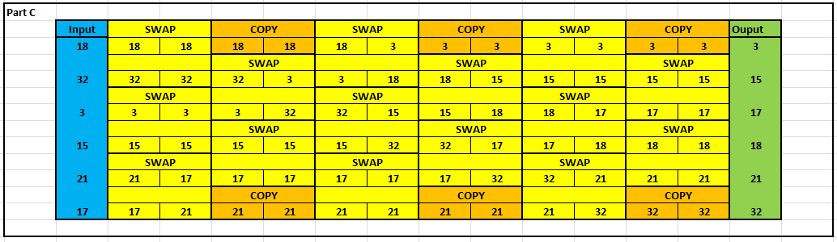

The yellow boxes swap the smallest to the top, while the copy just copies the value across so that the swap function can get the number.

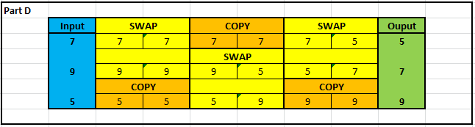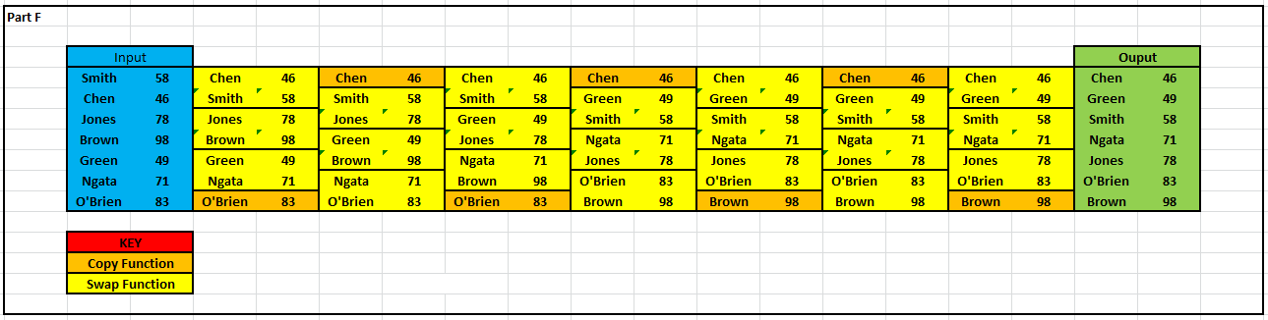

I used the same code for the numbers, but modified where the info was copied from to one cell to the left, therefore copying the name and not the number.

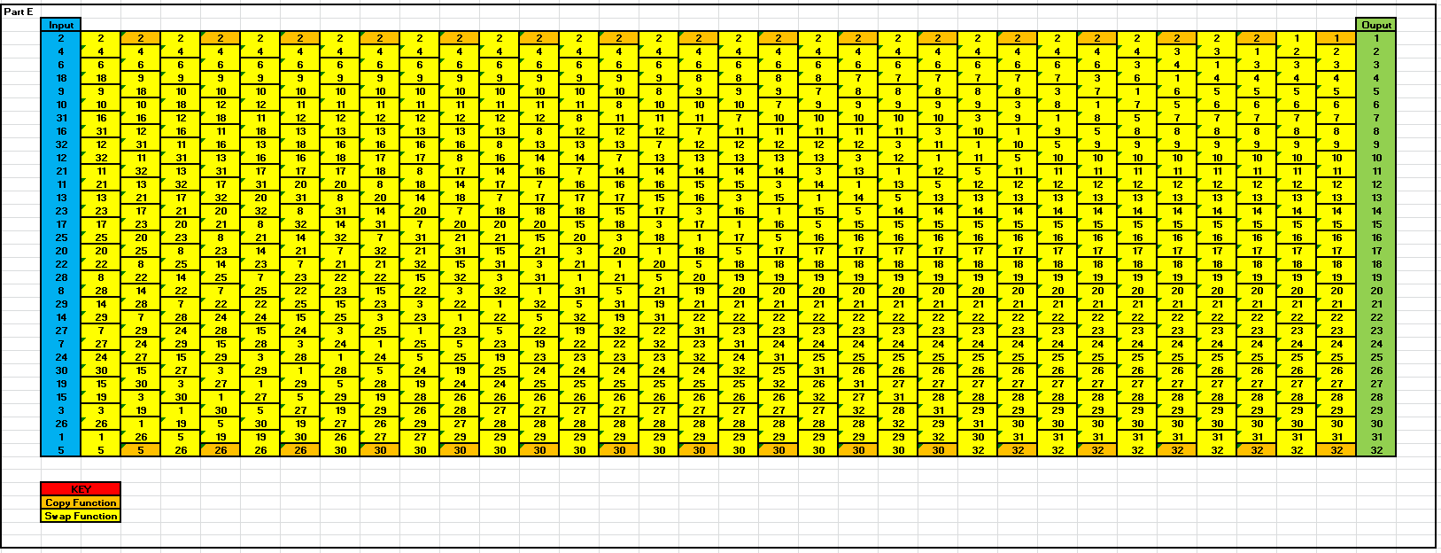

I made the 32 sorter compact by removing the labels and adding a key so you can still understand what is happening, but it is 1/3rd of the height